Auto Selection of any Available Phase in 3 Phase Supply System

This project is designed with an aim to provide uninterrupted AC mains supply that is 230 volts to a single-phase load. This is achieved by automatic changeover of the load from the missing phase to the next available phase in a 3-phase system. It is often noticed that power interruption in the distribution system is about 70% for single phase faults while the two other phases are in normal condition. Thus, in any commercial or domestic power providing system wherever three phases are offered, it’s wise to possess automatic shift system for uninterrupted power to essential loads in the event of missing phase. In this three-phase supply system, the auto selection is achieved by using a set of relays interconnected in such a way that if one of the relays feeding to the load remains energized always. Under the phase failure condition, the corresponding step-down transformer is turned on using a transistor assembly. Here, we are having three phases namely the R phase, Y phase, and B phase. To control the switching of the phase, there are three switches. Led which is placed on left is used to indicate which phase is on or off, the led and relays placed on the right indicates, which supply is providing power to the load.

Block Diagram
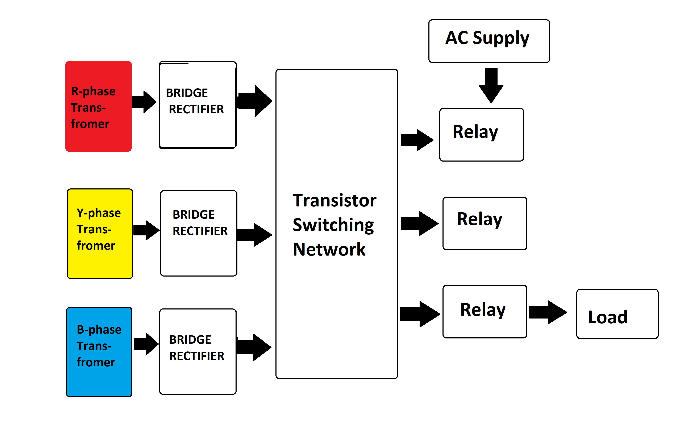

Hardware Specifications

- Regulator

- Relay
- Switches

- Resistor

- Diode
- Capacitor

- Transformer

- Crystal Oscillator
- Resistors

- Capacitors

- Transistors
- Cables and Connectors

- Diodes

- PCB and Breadboards
- LED

- Transformer/Adapter

- Push Buttons
- Switch

- IC

- IC Sockets

